Chapter 3 Questions and Answers

- Draw a sketch of the Four Pillars of Design. Include a brief description of each pillar and explain how each part relates to the others.
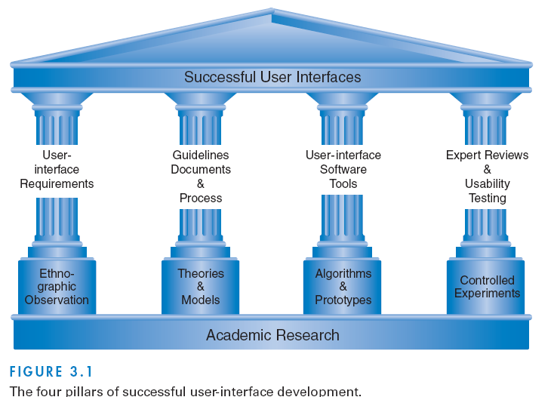
Academic research is the foundation of user design. Ethnographic observation informs user interface requirements. Theories and models structure the production of guidelines documents and processes. Algorithms and Prototypes assist the development of user-interface software tools. Scientific controls give validity to usability testing.
- What is rapid contextual design? Describe the steps. It’s a design development method:
Contextual inquiry. Plan for, prepare, and then conduct field interviews to observe and understand the work tasks being performed. Review business practices.
Interpretation sessions and work modeling. Hold team discussions to draw conclusions based on the contextual inquiry, including gaining an understanding of the workflow processes in the organization as well a cultural and policy impacts on work performed. Capture key points (affinity notes).
Model consolidation and affinity diagram building. Present the data gathered to date from users and the interpretation and work modeling to a larger, targeted population to gain insight and concurrence. Consolidate the work models to illustrate common work patterns and processes and create affinity diagrams (hierarchical representations of the issues to address user needs.
Persona development. Develop personas (fictitious characters) to represent the different user types within a targeted demographic that might use a site or product (Cooper, 2004). This aids the team in communicating the needs of the users and bringing those user needs to fruition. Examples of personas, at a high level, are: 1) 22-year-old male with 5 years of video game playing experience, or 2) 70-year-old female using computer only for e-mail and digital photo sharing.
Visioning. Review and “walk” the consolidated data, sharing the personas created. The visioning session helps define how the system will streamline and transform the work of the users. Capture key issues and ideas using flipcharts or any media that will facilitate expressing the vision of the revised business processes.
Storyboarding. The vision guides the detailed redesign of user tasks usingpictures and graphs to describe the initial user-interface concepts, business rules, and automation assumptions. Storyboarding defines and illustrates the “to be built” assumptions.
User environment design. The single, coherent representation of the users and the work to be performed is expressed in the user environment design (UED). The UED is built from the storyboards.
Interviews and evaluations with paper prototypes and mock-ups. Conduct interviews and tests with actual users, beginning with paper prototypes and then moving on to higher-fidelity prototypes. Capturing the results of the interviews aids in ensuring that the systems will meet end-user requirements.
- What is ethnographic observation? Describe an ethnographic observation process that produces accurate qualitative and quantitative data about users’ experiences.
Observing users in their work or home environments. Ethnographic researchers listen and observe carefully, sometimes stepping forward to ask questions and participate in activities. As ethnographers, user-interface designers gain insight into individual behavior and the organizational context. User-interface designers usually need to limit this process to a period of days or even hours to obtain the relevant data needed to influence a redesign forward to ask questions and participate in activities.
Preparation
- Understand policies in work environments and family values in homes.
- Familiarize yourself with the existing interface and its history.
- Set initial goals and prepare questions.
- Gain access and permission to observe or interview.
Field study
- Establish a rapport with all users.
- Observe or interview users in their setting, and collect subjective and objective quantitative and qualitative data.
- Follow any leads that emerge from the visits.
- Record your visits.
Analysis
- Compile the collected data in numerical, textual, and multimedia databases.
- Quantify data and compile statistics.
- Reduce and interpret the data.
- Refine the goals and the process used.
Reporting
- Consider multiple audiences and goals.
- Prepare a report and present the findings.
- What is participatory design? Summarize the potential advantages and disdvantages of participatory design.
The direct involvement of people in the collaborative design of the things and technologies they use. Advantages: More user involvement brings more accurate information about tasks and an opportunity for users to influence design decisions. Also, the sense of participation that builds users’ ego investment in successful implementation may be the biggest influence on increased useracceptance of the final system. Disadvantages: extensive user involvement may be costly and may lengthen the implementation period. It may also generate antagonism from people who are not involved or whose suggestions are rejected, and potentially force designers to compromise their designs to satisfy incompetent participants
- Describe the role of scenario development in creating interface designs.
Descriptions of situations that portray typical needs of potential users. Scenarios can represent common or emergency situations with both novice and expert users. Personas can also be included in scenario generation. Scenarios take what is known about users, their needs/tasks, and puts it into a narrative form that effectively communicates design needs to stakeholders.
- What are the benefits of creating a social impact statement?
Preventing problems that could be expensive to repair, improving privacy protection, minimizing legal challenges, and creating more satisfying work environments.
Terms and Concepts to Know:
- User-Centered Design
- The Four Pillars of Design
- Rapid Contextual Design
- Ethnographic Observation
- Participatory Design
- Scenario Development
- Social Impact Statement

